Aesthetic Impact Informational Services, LLC
Remote Viewing Target Discussion
January 2nd, 2013
Target 130102
Sphere Within A Sphere

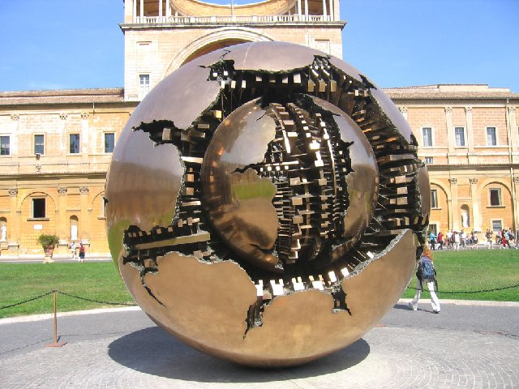

Italian sculptor Arnaldo Pomodoro is known to construct enormous spheres with layers of complexities. One of his monumental orbs stands tall as the centerpiece of the Courtyard of the Pinecone at the Vatican Museum. The structure titled Sfera con Sfera, translated as Sphere within a Sphere, is a bronze statue that appears golden as the sun shines down on it. It is 4 meters (a little over 13 feet) in diameter.
The Milan-based artist began his series of spheres in the 60's with Sphere no. 1 and has continued designing the globe-like pieces, each depicting a different map of destruction. Each tremendous ball is fractured, revealing an intricate interior that unveils yet another cracking orb. The design of the internal layers seem to mimicking the gears of a clock or the inner workings of a grand piano, making it appear very complicated.
Because of the sculptural installation's round shape, it also echoes the form of Earth. It isn't absolutely clear what the artist's intentions are, but it gives off the impression that it is reflecting the complexity of our world and how easily it can be torn apart.
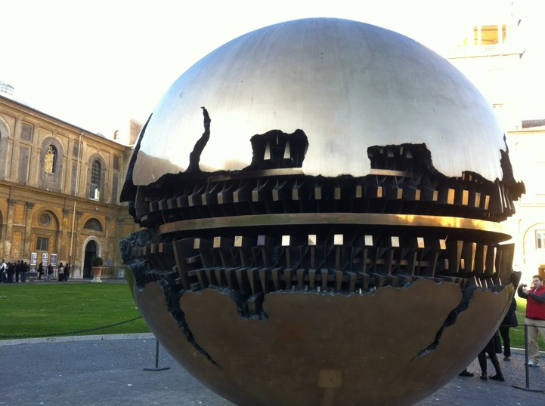

http://www.mymodernmet.com/profiles/blogs/arnaldo-pomodoro-sphere-within-a-sphere

