Aesthetic Impact Informational Services, LLC

Target 121107
Cranberry Harvest
November 07, 2012

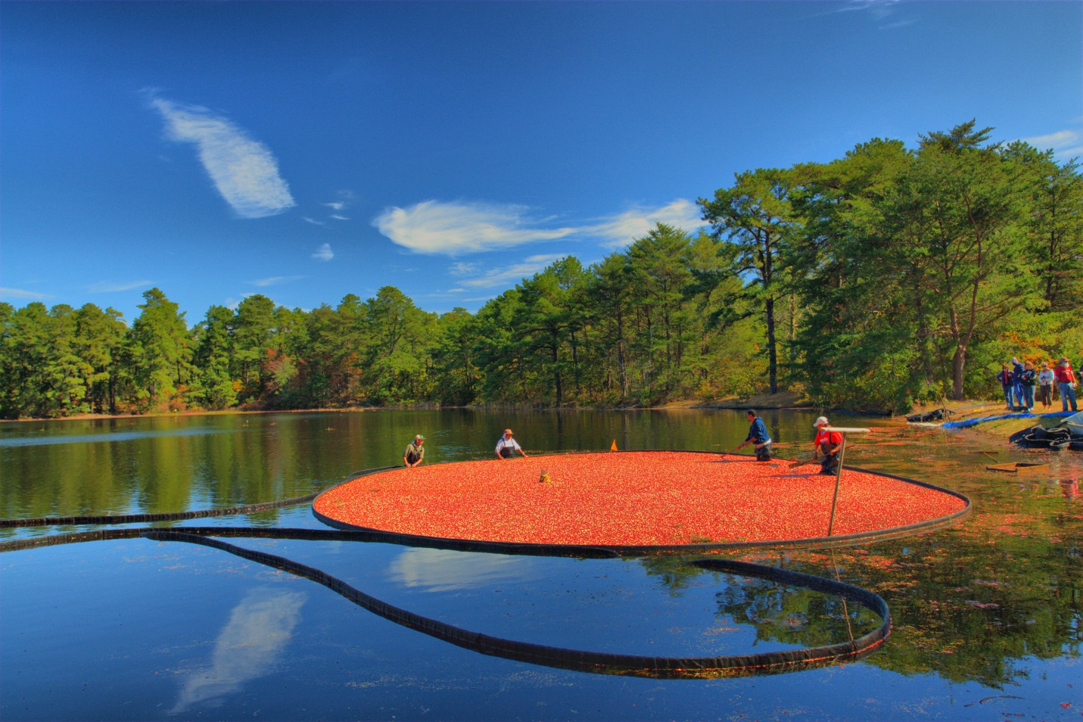
Geography and Bog Method
Cranberries are a major commercial crop in the U.S. states of Massachusetts, New Jersey, Oregon, Washington, and Wisconsin, as well as in the Canadian provinces of British Columbia, New Brunswick, Ontario, Nova Scotia, Prince Edward Island, Newfoundland and Quebec. Wisconsin is the leading producer of cranberries, with over half of U.S. production.[8] Massachusetts is the second largest U.S. producer. A very small production is found in southern Argentina and Chile, the Netherlands,[9] and Eastern Europe.[citation needed]
Historically, cranberry beds were constructed in wetlands. Today cranberry beds are constructed in upland areas with a shallow water table. The topsoil is scraped off to form dykes around the bed perimeter. Clean sand is hauled in to a depth of four to eight inches. The surface is laser leveled flat to provide even drainage. Beds are frequently drained with socked tile in addition to the perimeter ditch. In addition to making it possible to hold water, the dykes allow equipment to service the beds without driving on the vines. Irrigation equipment is installed in the bed to provide irrigation for vine growth and for spring and autumn frost protection.
A common misconception about cranberry production is that the beds remain flooded throughout the year. During the growing season cranberry beds are not flooded, but are irrigated regularly to maintain soil moisture. Beds are flooded in the autumn to facilitate harvest and again during the winter to protect against low temperatures. In cold climates like Wisconsin, Maine, and eastern Canada, the winter flood typically freezes into ice, while in warmer climates the water remains liquid. When ice forms on the beds, trucks can be driven onto the ice to spread a thin layer of sand that helps to control pests and rejuvenate the vines. Sanding is done every three to five years.
Harvesting
Cranberries are harvested in the fall when the fruit takes on its distinctive deep red color. This is usually in September through the first part of November. To harvest cranberries, the beds are flooded with six to eight inches of water above the vines. A harvester is driven through the beds to remove the fruit from the vines. For the past 50 years, water reel type harvesters have been used. Harvested cranberries float in the water and can be corralled into a corner of the bed and conveyed or pumped from the bed. From the farm, cranberries are taken to receiving stations where they are cleaned, sorted, and stored prior to packaging or processing.
Although most cranberries are wet-picked as described above, 5–10% of the US crop is still dry-picked. This entails higher labor costs and lower yield, but dry-picked berries are less bruised and can be sold as fresh fruit instead of having to be immediately frozen or processed. Originally performed with two-handed comb scoops, dry picking is today accomplished by motorized, walk-behind harvesters which must be small enough to traverse beds without damaging the vines.
White cranberry juice is made from regular cranberries that have been harvested after the fruits are mature, but before they have attained their characteristic dark red color. Yields are lower on beds harvested early and the early flooding tends to damage vines, but not severely.
Cranberries for fresh market are stored in shallow bins or boxes with perforated or slatted bottoms, which deter decay by allowing air to circulate. Because harvest occurs in late autumn, cranberries for fresh market are frequently stored in thick walled barns without mechanical refrigeration. Temperatures are regulated by opening and closing vents in the barn as needed. Cranberries destined for processing are usually frozen in bulk containers shortly after arriving at a receiving station.
Information retrieved from Wikipedia 10/14/12. http://en.wikipedia.org/wiki/Cranberry
Image retrieved from:

