Aesthetic Impact Informational Services, LLC
Target 120926
Tipp-Elizabeth Road Bridge
Site Images August 2012 provided by Teresa Frisch

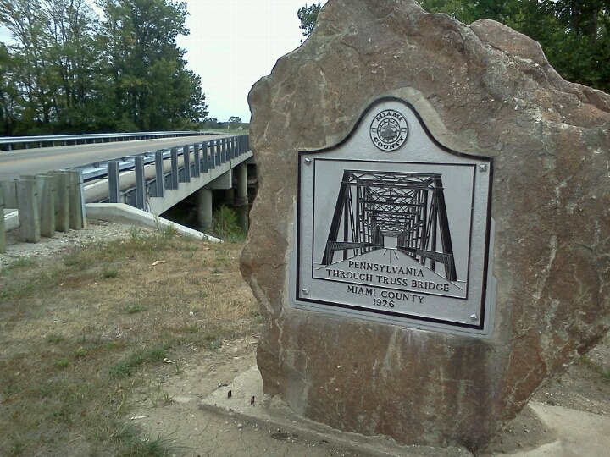
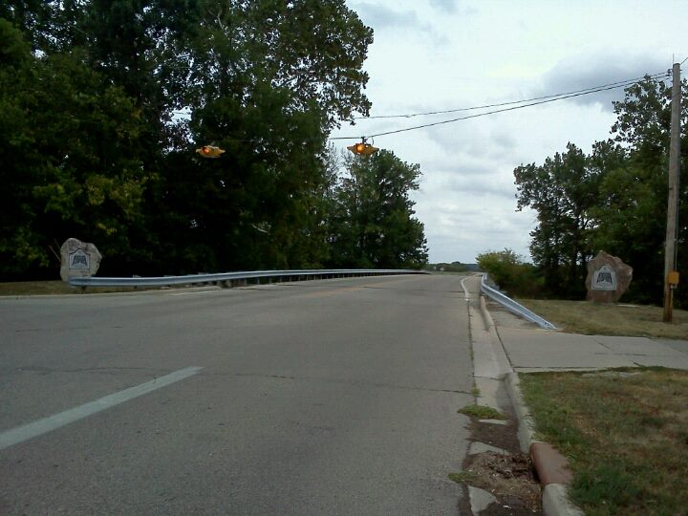
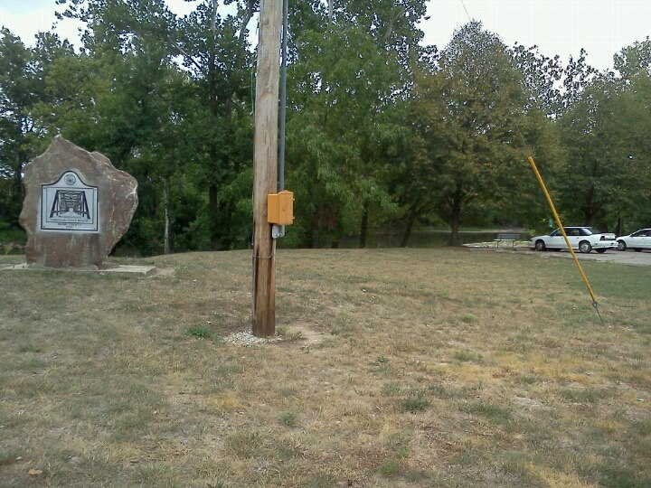
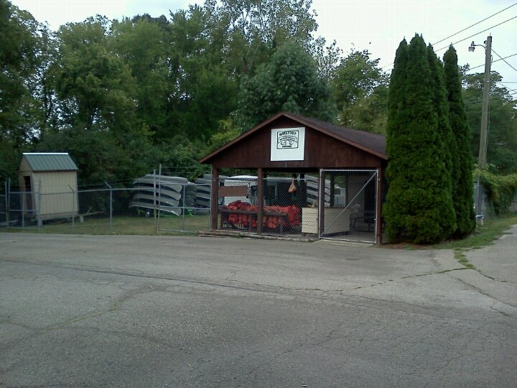
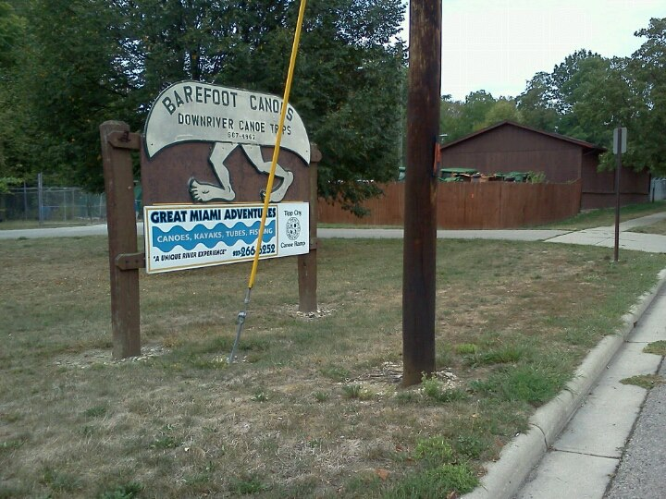
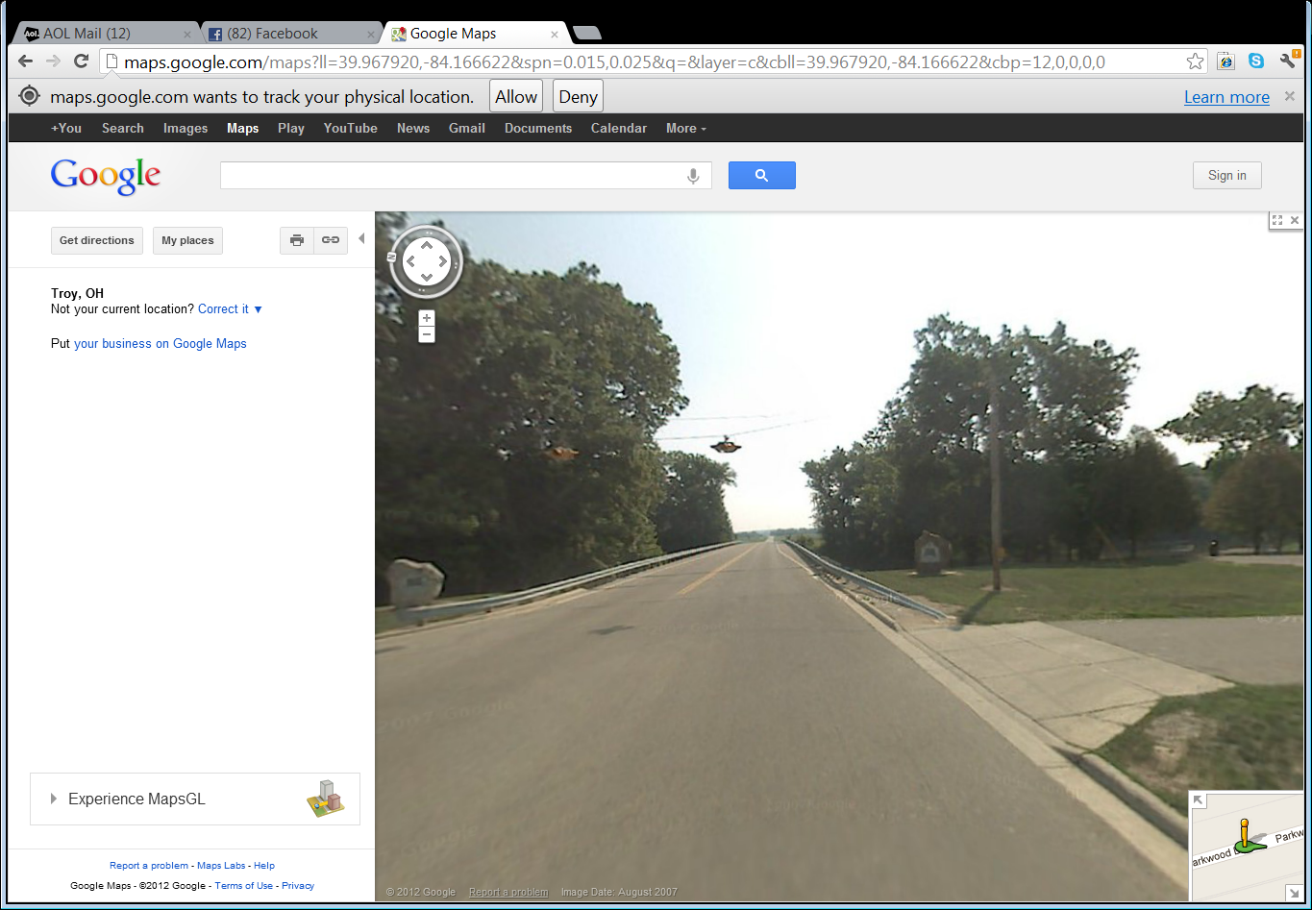
Fair Use / Teaching: Googlemaps - Streetview. Retrieved 9/1/12.
http://maps.google.com/maps?ll=39.967920,-84.166622&spn=0.015,0.025&q=&layer=c&cbll=39.967920,-84.166622&cbp=12,0,0,0,0
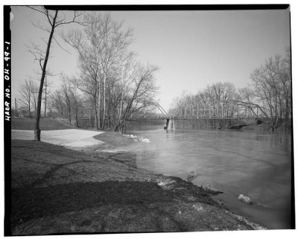
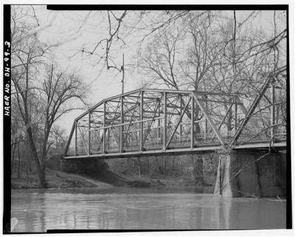
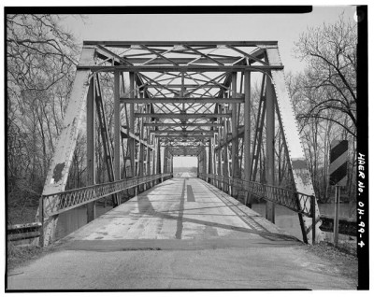
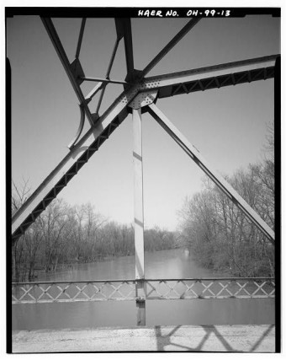

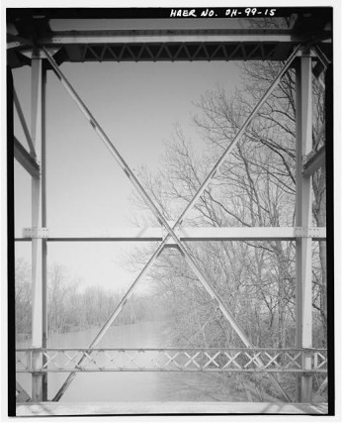
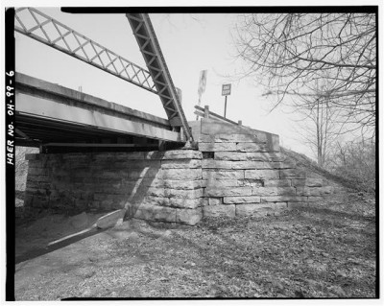
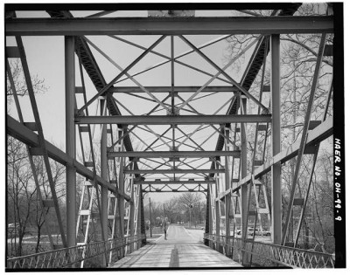
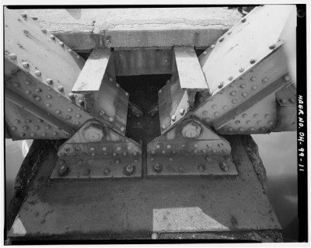
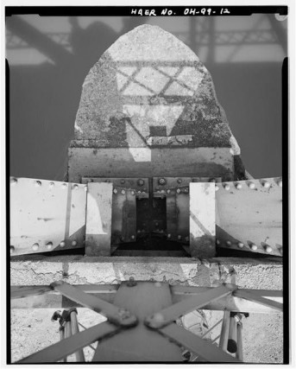
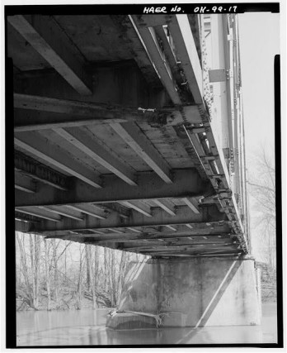

Fair Use / Teaching: retrieved 9/1/12
http://bridgehunter.com/oh/miami/tipp-elizabeth-road/

Facts

Overview
Pennsylvania through truss bridge over Great Miami River on Tipp-Elizabeth Road
Location
Tipp City, Miami County, Ohio
Status
Bridge has been replaced
History
Built 1926; rehabilitated 1957
Design
Pennsylvania through truss
Dimensions
Length of largest span: 145.0 ft.
Total length: 295.0 ft.
Deck width: 17.4 ft.
Recognition
Eligible for the National Register of Historic Places
Approximate latitude, longitude
+39.96792, -84.16662 (decimal degrees)
39°58'05" N, 84°09'60" W (degrees°minutes'seconds")
Approximate UTM coordinates
16/741986/4428041 (zone/easting/northing)
USGS topographic map
Tipp City
Inventory numbers
ODOT 5535301 (Ohio Dept. of Transportation structure file number)
BH 43850 (Bridgehunter.com ID)
Inspection (as of 05/1991)
Deck condition rating: Poor (4 out of 9)
Superstructure condition rating: Serious (3 out of 9)
Substructure condition rating: Serious (3 out of 9)
Appraisal: Structurally deficient
Sufficiency rating: 9.4 (out of 100)
Average daily traffic (as of 1979)
2,000
Types of Bridge Design
http://pghbridges.com/basics.htm

http://bridgehunter.com/photos/15/18/151822-M.jpg
http://www.google.com/imgres?q=tipp+city+ohio+pennsylvania+bridge&start=265&hl=en&sa=X&biw=1416&bih=856&tbm=isch&prmd=imvns&tbnid=aRjr-O8xc1cfhM:&imgrefurl=http://bridgehunter.com/oh/miami/tipp-elizabeth-road/&imgurl=http://bridgehunter.com/photos/15/18/151823-M.jpg&w=400&h=318&ei=pRNFUKnpIeHe0QGSxoGQDA&zoom=1&iact=hc&vpx=202&vpy=123&dur=1847&hovh=200&hovw=252&tx=94&ty=155&sig=106043756881316963809&page=10&tbnh=160&tbnw=215&ndsp=30&ved=1t:429,r:24,s:265,i:370
http://www.google.com/imgres?q=tipp+city+ohio+pennsylvania+bridge&start=295&hl=en&sa=X&biw=1416&bih=856&tbm=isch&prmd=imvns&tbnid=KwbJqWuMYlvqeM:&imgrefurl=http://bridgehunter.com/oh/miami/tipp-elizabeth-road/&imgurl=http://bridgehunter.com/photos/15/18/151835-M.jpg&w=346&h=427&ei=hxRFUOytBYLx0gHpoIDQCw&zoom=1&iact=hc&vpx=193&vpy=316&dur=4794&hovh=249&hovw=202&tx=94&ty=197&sig=106043756881316963809&page=11&tbnh=169&tbnw=137&ndsp=30&ved=1t:429,r:0,s:295,i:6
http://www.google.com/imgres?q=tipp+city+ohio+pennsylvania+bridge&start=265&hl=en&sa=X&biw=1416&bih=856&tbm=isch&prmd=imvns&tbnid=OwBOB_YyiyQJEM:&imgrefurl=http://bridgehunter.com/oh/miami/tipp-elizabeth-road/&imgurl=http://bridgehunter.com/photos/15/18/151825-M.jpg&w=400&h=319&ei=wRRFUP6hC8rb0QHcsoDoCg&zoom=1&iact=hc&vpx=761&vpy=123&dur=71&hovh=200&hovw=251&tx=145&ty=127&sig=106043756881316963809&page=10&tbnh=160&tbnw=215&ndsp=30&ved=1t:429,r:27,s:265,i:379
http://www.google.com/imgres?q=tipp+city+ohio+pennsylvania+bridge&start=265&hl=en&sa=X&biw=1416&bih=856&tbm=isch&prmd=imvns&tbnid=Mp9GQY-owh84aM:&imgrefurl=http://bridgehunter.com/oh/miami/tipp-elizabeth-road/&imgurl=http://bridgehunter.com/photos/15/18/151828-M.jpg&w=400&h=315&ei=3RRFUPXCMYSu0AG71YDoCw&zoom=1&iact=hc&vpx=988&vpy=124&dur=1827&hovh=199&hovw=253&tx=143&ty=93&sig=106043756881316963809&page=10&tbnh=160&tbnw=217&ndsp=30&ved=1t:429,r:28,s:265,i:382
http://www.google.com/imgres?q=tipp+city+ohio+pennsylvania+bridge&start=265&hl=en&sa=X&biw=1416&bih=856&tbm=isch&prmd=imvns&tbnid=9L1FYGQK7E04mM:&imgrefurl=http://bridgehunter.com/oh/miami/tipp-elizabeth-road/&imgurl=http://bridgehunter.com/photos/15/18/151822-M.jpg&w=400&h=321&ei=_hRFUNerFOHs0gGKtYGYCw&zoom=1&iact=rc&dur=385&sig=106043756881316963809&page=10&tbnh=151&tbnw=188&ndsp=30&ved=1t:429,r:22,s:265,i:363&tx=96&ty=81
http://www.google.com/imgres?q=tipp+city+ohio+pennsylvania+bridge&start=265&hl=en&sa=X&biw=1416&bih=856&tbm=isch&prmd=imvns&tbnid=iplJnpKu_hKuuM:&imgrefurl=http://bridgehunter.com/oh/miami/tipp-elizabeth-road/&imgurl=http://bridgehunter.com/photos/15/18/151833-M.jpg&w=340&h=427&ei=PBVFUOf1HaTv0gG9zIGwCw&zoom=1&iact=hc&vpx=1171&vpy=209&dur=10192&hovh=252&hovw=200&tx=152&ty=140&sig=106043756881316963809&page=10&tbnh=160&tbnw=127&ndsp=30&ved=1t:429,r:29,s:265,i:385

