Aesthetic Impact Informational Services, LLC
Remote Viewing Target Discussion 120912
York Center School – Noble County, Indiana
September 12, 2012
Commentary by Lyn Buchanan
CRV Trainer and Former Member Military Intelligence Unit STAR GATE
Blind Tasking: 1. Describe the building and its purpose in 2011.
2. Describe the building and its purpose in 1967 and 1968.
Coordinates: 120912
In Session Move Command Exercise: Move to the designated time and describe.
Photo in 2011 – Albion Apostolic Church Camp
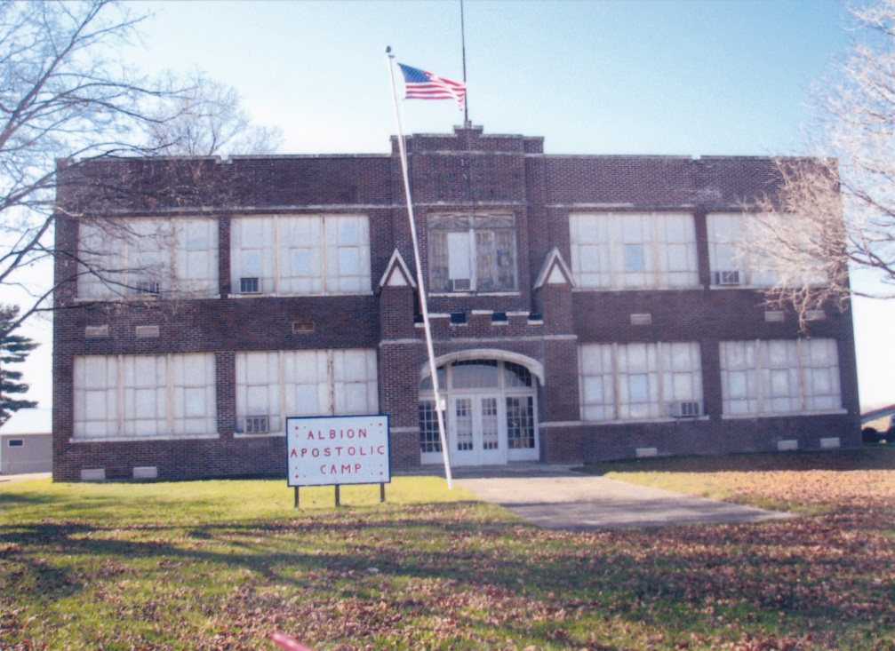
York Center School was a country school in York Township, Noble County, Indiana. The two story structure was made of brick, with terrazzo floors. The basement housed the kitchen, large cafeteria, janitor’s room and the coal-fired boiler which circulated steam heat to throughout the building. “Clinkers” were burned coal and found outside at the base of the chimney.
Five yellow school buses delivered students daily. Grades one through eight were housed in five classrooms – two on the first floor and three on the second. The office and a small library were located on the second floor. The gymnasium was halfway between the first and second stories. The gym had a large stage flanked by wine colored velvet curtains at the west end, but did not have bleachers.
The school was situated in the middle of rural farmland. Agricultural sights, sounds and smells were common; fields being plowed in the spring and wheat, corn and oats being harvested in the fall. It was not uncommon to hear farm animals such as pigs, chicken and cattle moving about or clanging at feeders. Students didn’t need the sound of the tractors to tell them when barns were cleaned and accumulated manure was spread onto the fields as fertilizer. In 1840 – 1855 the area was also known for its Iron Ore Bogs. There is a two track railroad to the north, with a truss bridge that was still in use in 1967-68, but has since been replaced. A river bordered by bogs winds its way through the farmland a few hundred yards north of the railroad tracks.
Dale Guthrie was our Principal for many years, entertaining us with stories of how the apple tree in his back yard produced several kinds of apples. Such was our exotic introduction to Botany and grafting. Ruth Buffenbarger, sister of Secretary of State Earl Butz taught first and second grades at York Center for many years.
The school is now used by the Apostolic Church as a camp. Outbuildings have been added and repair work noted in the masonry equipment seen on the north side of the school. The original slide, swings and teeter-totters are still there. The large and popular pump-driven merry-go-round is gone. The once-small pine tree that I worried would be killed by deep snow and tried to “save” is one of the few pines still on the site, but not due to the efforts of a second grader. I still smile when I remember. All images except the trestle bridge courtesy of Teresa Frisch.

Masonry repair equipment
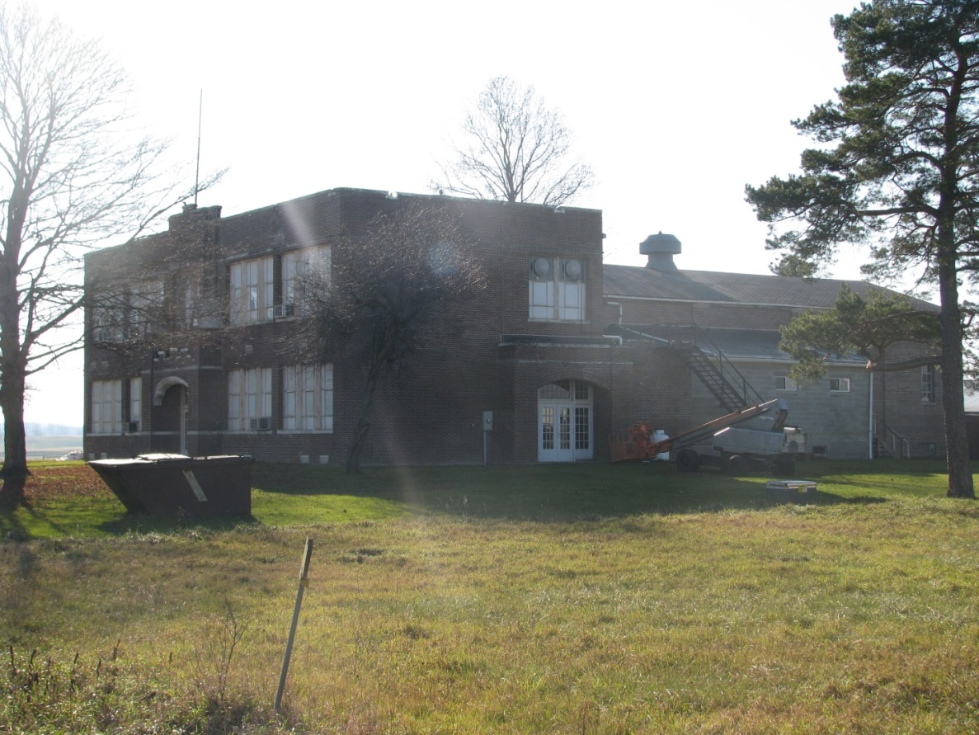
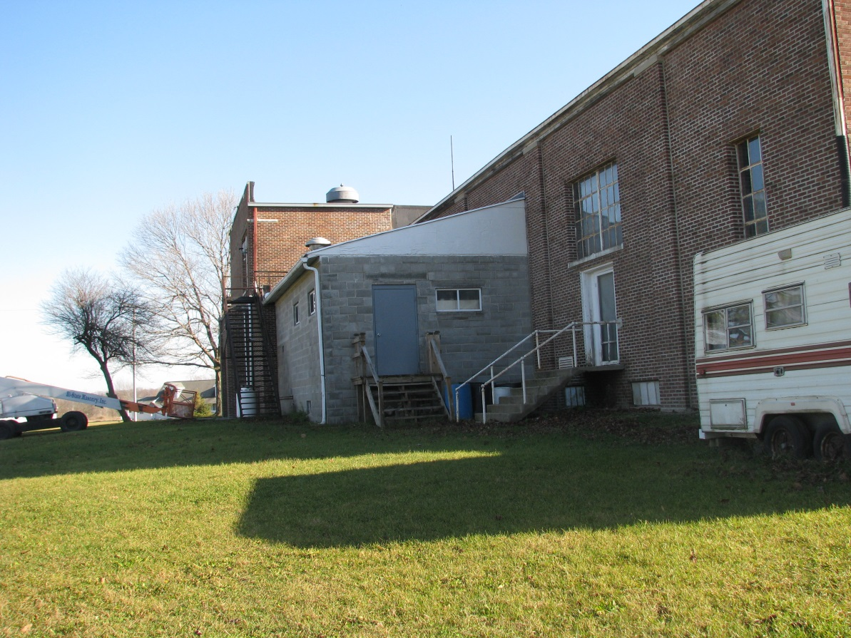
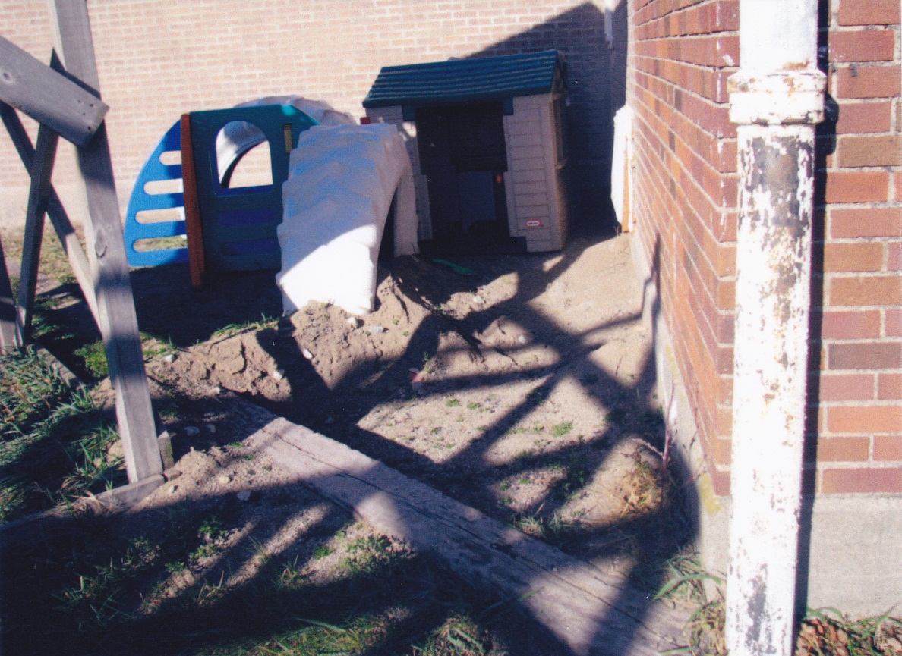
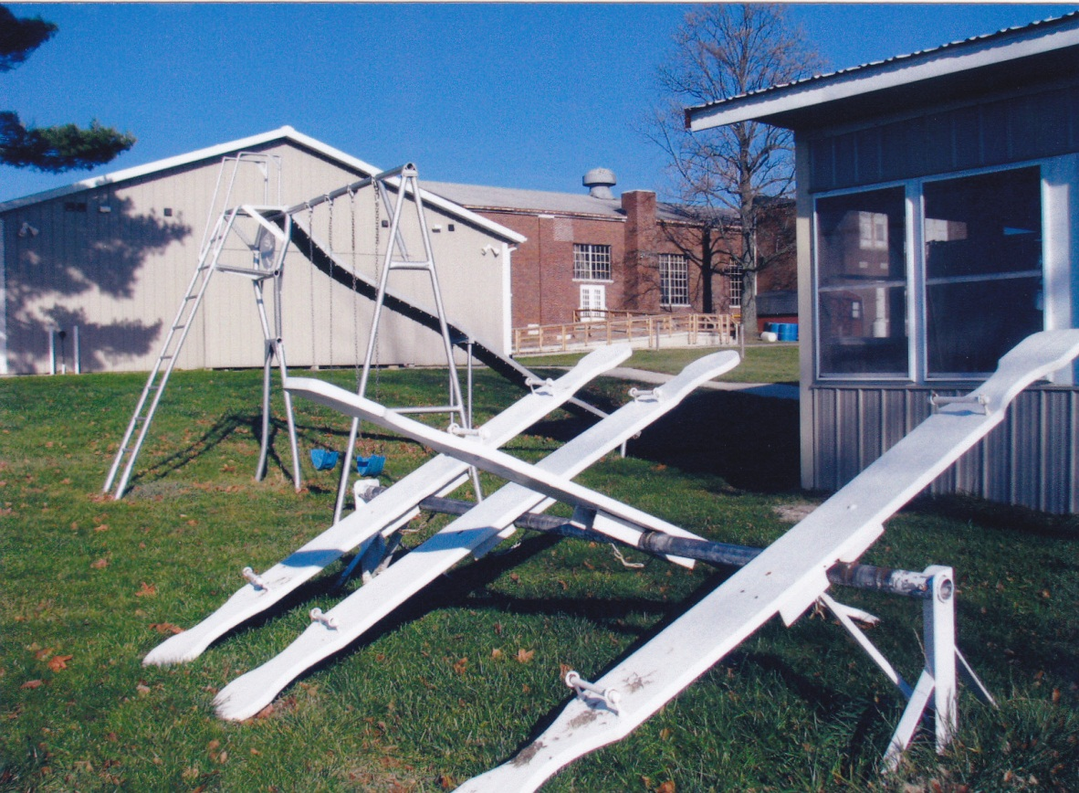

Original slide and swings with working farm in the background.
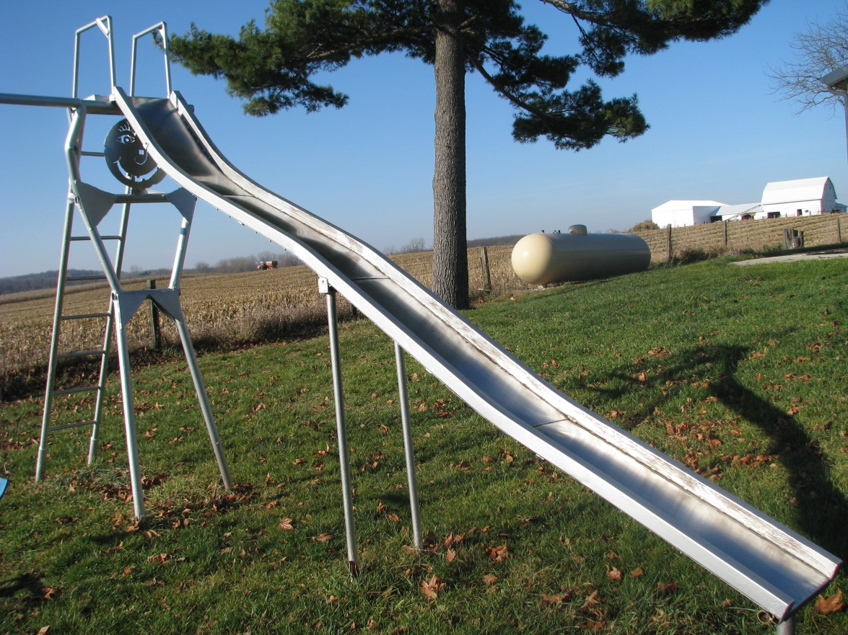
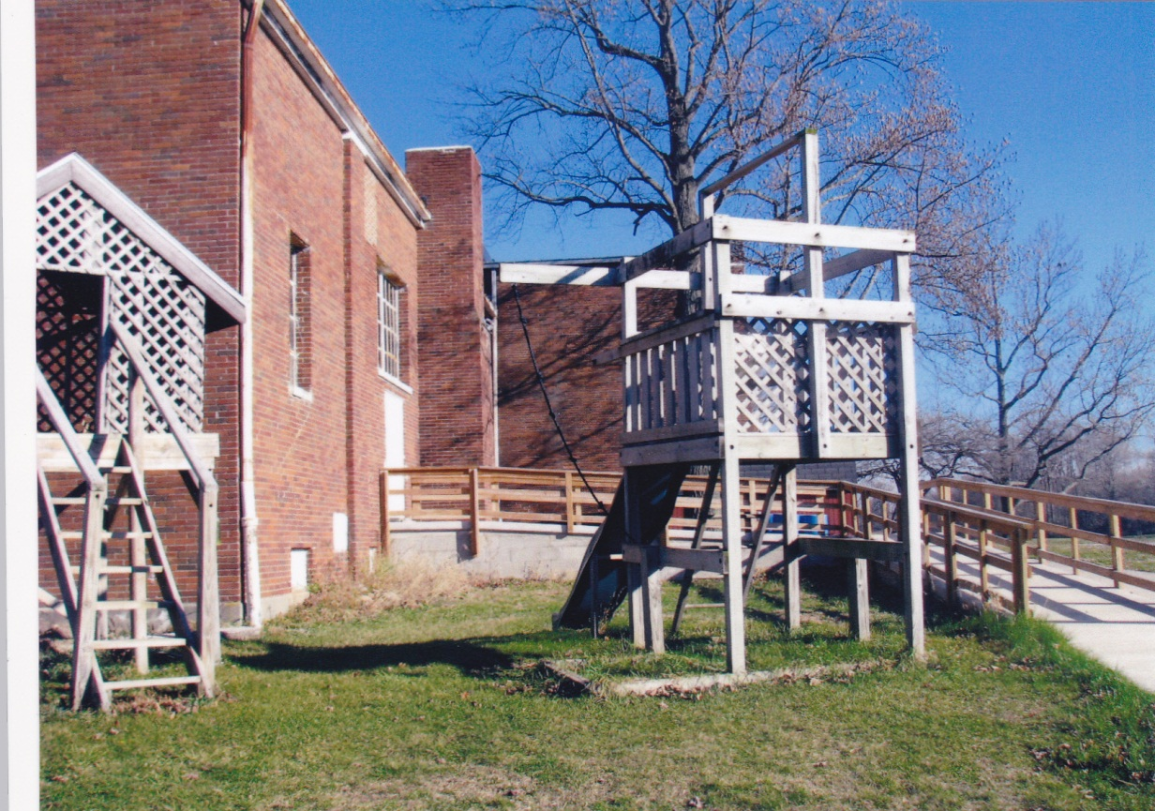

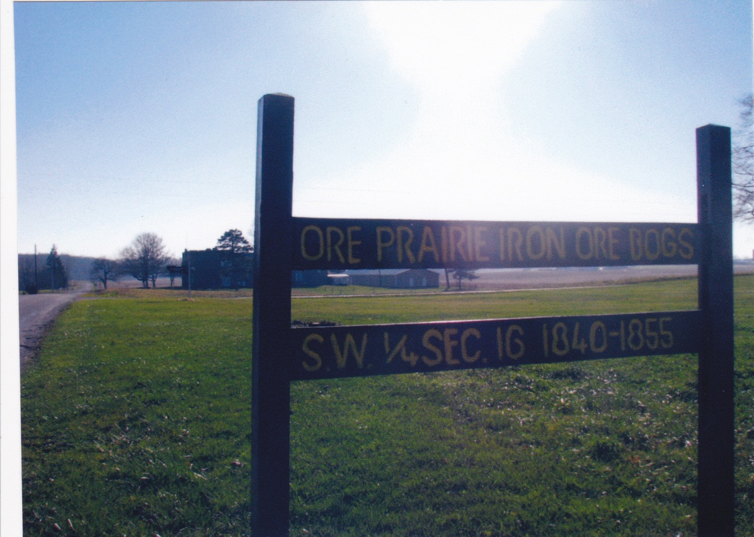
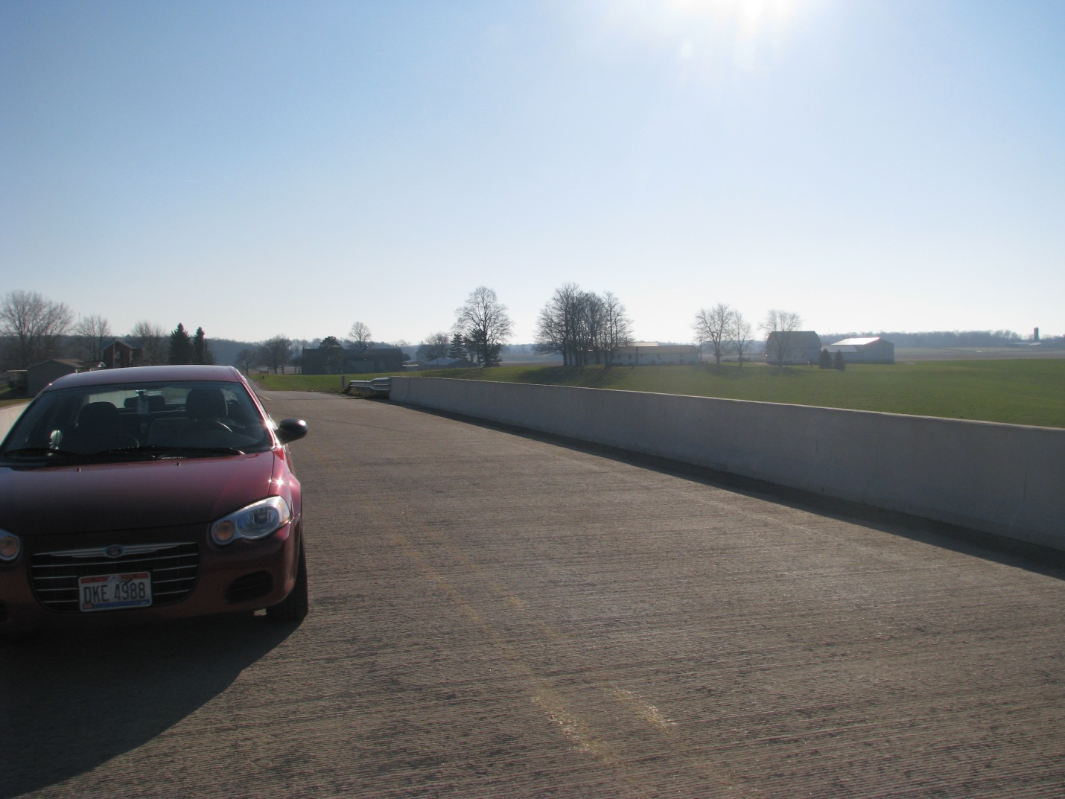
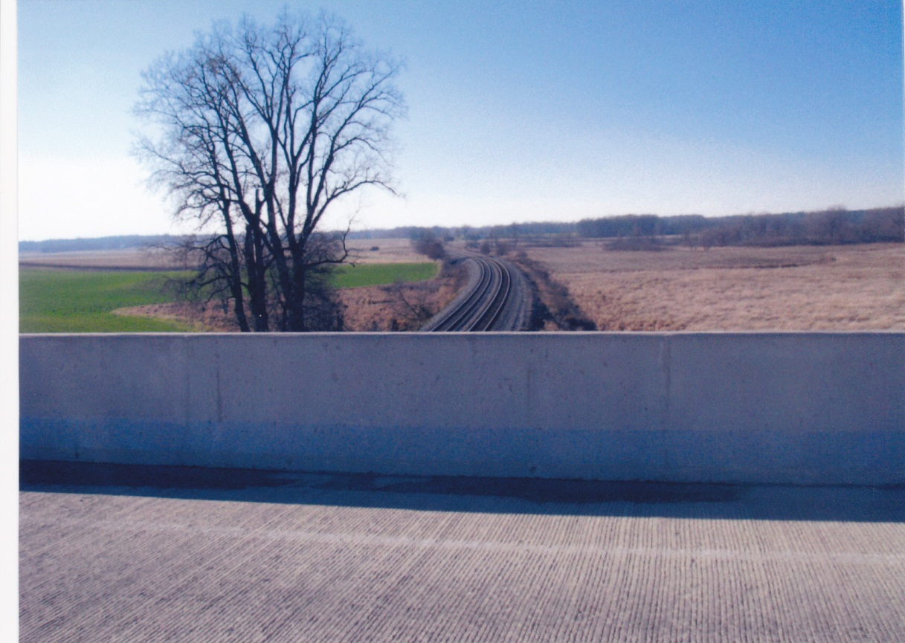
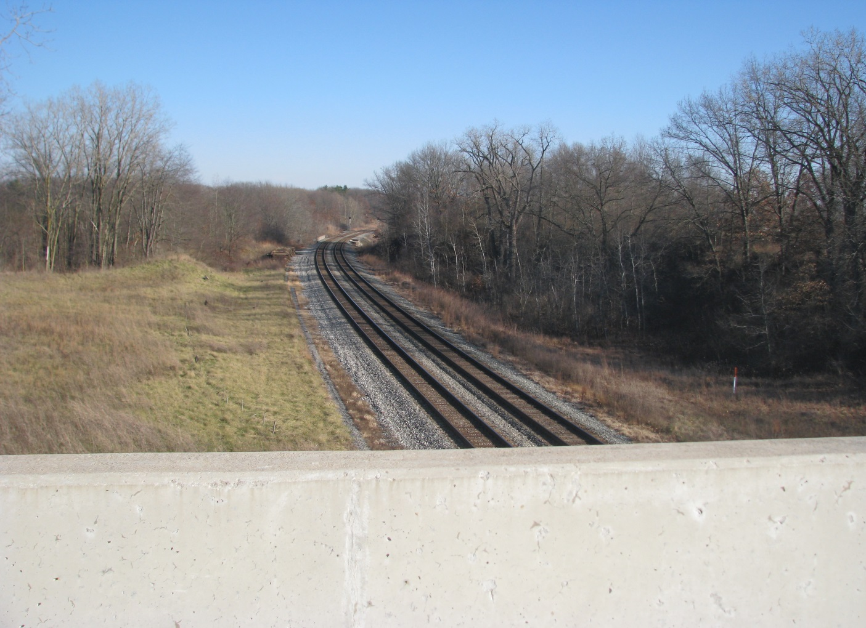

Bing Map Retrieved 9/11/12

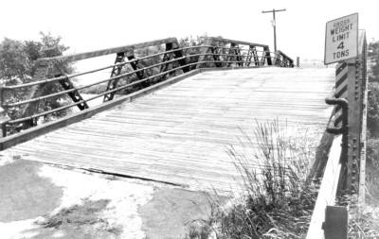
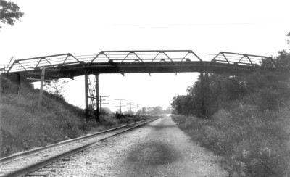
Retrieved 9/12/12 http://bridgehunter.com/in/noble/5700068/
Images: Fair Use For Teaching

