Target 120829
U2 - Where The Streets Have No Name – Los Angeles Rooftop Republic Liquor Store Concert (Full Version - Live) Video link: http://www.youtube.com/watch?v=QQxl9EI9YBg
Note: the band was on the rooftop of more than just the liquor store. Fish store on the left and main market on the right. The video had political undertones as the band was hoping to draw a huge crowd, create traffic issues and possibly cause them to be arrested.
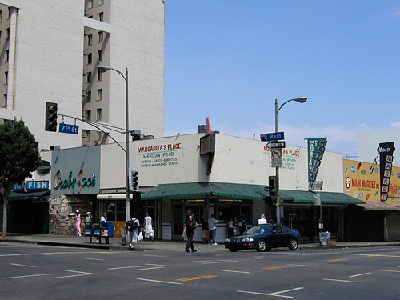
From Wiki: fair use statement in red – retrieved 4/30/13
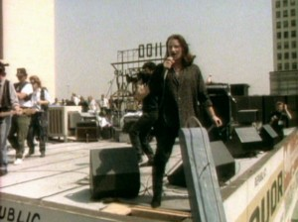
This image is a screenshot from a copyrighted music video or promotional video for a music artist, and the copyright for it is most likely held by the producers of the video and possibly also by the music artist. It is believed that the use of a limited number of web-resolution screenshots for identification and critical commentary on the music video in question on the English-language Wikipedia, hosted on servers in the United States by the non-profit Wikimedia Foundation, qualifies as fair use under United States copyright law. Any other uses of this image, on Wikipedia or elsewhere, may be copyright infringement. See Wikipedia:Non-free content for more information.

Background info: wiki – retrieved 4/30/13
http://en.wikipedia.org/wiki/Where_the_Streets_Have_No_Name
The video begins with an aerial shot Los Angeles, and clips of radio broadcasts are heard with disc jockeys stating that U2 is planning on performing a concert downtown and expecting crowds of 30,000 people. Police show up to the set and inform the band's crew of the security issue that the film shoot is causing, due to the large number of people who are coming to watch the performance. Two minutes into the video, U2 are seen on the roof of a liquor store and perform "Where the Streets Have No Name" to a large crowd of people standing in the streets surrounding the building. Towards the end of the song, the police tell the crew that the performance is about to be shut down, and eventually police walk onto the roof while the crowd are booing the police.
The video for "Where the Streets Have No Name" was directed by Meiert Avis and produced by Michael Hamlyn and Ben Dossett. The band attracted over 1,000 people during the video's filming, which took place on the rooftop of a liquor store in Downtown Los Angeles on 27 March 1987.[24] The band's performance on a rooftop in a public place was a reference to The Beatles' final concert, as depicted in the film Let It Be.[25]
"The object was to close down the streets. If there's one thing people in LA hate, it's streets closing down, and we've always felt bands should shake things up. We achieved it because the police stopped us filming. Were we worried about being arrested? Not at the time..."
—Adam Clayton[26]
During the shoot U2 played an eight-song set, which included four performances of "Where the Streets Have No Name".[25] Prior to filming, a week was spent reinforcing the roof of the liquor store to ensure it would not collapse if it were to be intruded by a group of fans. A backup generator was put on the roof so the shooting could continue in the event that the authorities shut off the power on the primary generator, which happened during filming.[27]
The depiction of the police attempting to shut down the video shoot due to safety concerns actually happened during filming, just as seen in the video. Hamlyn was almost arrested following a confrontation with the police.[28] According to Avis, the events depicted in the video show what actually happened that day "almost in real time", and that "getting busted was an integral part of the plan."[27] Band manager Paul McGuinness revealed in 2007 that much of the confrontation with the police was exaggerated; the group were hoping to get shut down by the authorities in order to dramatize the music video, but the police continually gave them extensions for shooting the video.[29] In the background of the video is a sign for The Million Dollar Hotel, which was rebuilt to create some interest, in case no one showed up at the film shoot.[27] Although the video is of a live performance, the audio used is from the studio-recorded version of the song.[30] The video won the Grammy Award for Best Performance Music Video at the 1989 Grammy Awards.[31]

